**3 - Amaliy topshiriq**

*Iqbolshoh Ilhomjonov*

1. Kitob nomli sinf yarating. Tarkibida statik a’zolar va statik metodlar mavjud bo’lsin.

#include <iostream>

using namespace std;

class Kitob

{

private:

    static string nom;

    static int bet;

    static int kitobxon;

public:

    static void Set(int b, int c)

    {

        bet = b;

        kitobxon = c;

    }

    static void Print()

    {

        cout << " 1) Kitob nomi : " << nom << endl;

        cout << " 2) Kitob bet : " << bet << endl;

        cout << " 3) Kitobxon soni : " << kitobxon << endl;

    }

};

string Kitob::nom = "Atom Odatlar";

int Kitob::bet = 350;

int Kitob::kitobxon = 4000;

int main()

{

    Kitob::Print();

    Kitob::Set(400, 5000);

    cout << "Malumot almashtirish" << endl;

    Kitob::Print();

    return 0;

}

// Natija

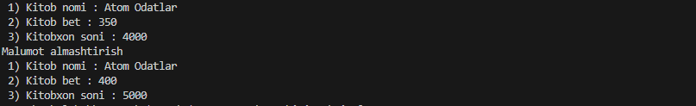

1. Noutbuk nomli sinf yarating. Tarkibida statik a’zolar va statik metodlar mavjud bo’lsin.

#include <iostream>

using namespace std;

class Noutbuk

{

private:

    static string nom;

    static string brend;

    static int narx;

public:

    static void Set(string b, int c)

    {

        brend = b;

        narx = c;

    }

    static void Print()

    {

        cout << " 1) Noutbuk nomi : " << nom << endl;

        cout << " 2) Noutbuk brend : " << brend << endl;

        cout << " 3) Narxi : " << narx << "$" << endl;

    }

};

string Noutbuk::nom = "Notebuk";

string Noutbuk::brend = "Lenevo";

int Noutbuk::narx = 1400;

int main()

{

    Noutbuk::Print();

    Noutbuk::Set("Apple", 2200);

    cout << "Malumot almashtirish" << endl;

    Noutbuk::Print();

    return 0;

}

// Natija

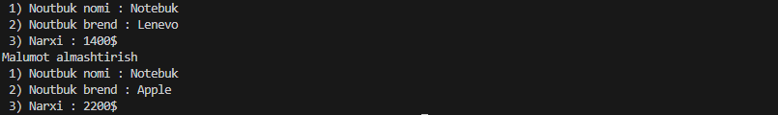

1. Fakultet nomli sinf yarating. Tarkibida statik a’zolar va statik metodlar mavjud bo’lsin.

#include <iostream>

using namespace std;

class Fakultet

{

private:

    static string nom;

    static int oqituvchi;

    static int talaba;

public:

    static void Set(int b, int c)

    {

        oqituvchi = b;

        talaba = c;

    }

    static void Print()

    {

        cout << " 1) Fakultet nomi : " << nom << endl;

        cout << " 2) O'qituvchilar soni : " << oqituvchi << endl;

        cout << " 3) Talabalar soni : " << talaba << endl;

    }

};

string Fakultet::nom = "Intelektular tizimlar";

int Fakultet::oqituvchi = 77;

int Fakultet::talaba = 1300;

int main()

{

    Fakultet::Print();

    Fakultet::Set(88, 1200);

    cout << "Malumot almashtirish" << endl;

    Fakultet::Print();

    return 0;

}

// Natija

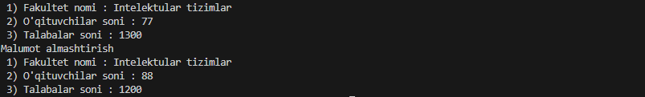

1. Guruh nomli sinf yarating. Tarkibida statik a’zolar va statik metodlar mavjud bo’lsin.

#include <iostream>

using namespace std;

class Guruh

{

private:

    static string nom;

    static string starsta;

    static int talaba;

public:

    static void Set(string b, int c)

    {

        starsta = b;

        talaba = c;

    }

    static void Print()

    {

        cout << " 1) Guruh nomi : " << nom << endl;

        cout << " 2) Starsta : " << starsta << endl;

        cout << " 3) Talabalar soni : " << talaba << endl;

    }

};

string Guruh::nom = "204-Dasturiy Injinering";

string Guruh::starsta = "Suxrob";

int Guruh::talaba = 30;

int main()

{

    Guruh::Print();

    Guruh::Set("Iqbolshoh", 25);

    cout << "Malumot almashtirish" << endl;

    Guruh::Print();

    return 0;

}

// Natija

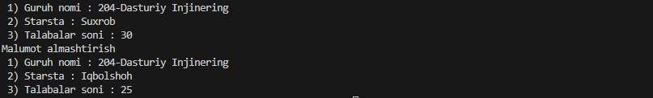

1. Kutubxona nomli sinf yarating. Tarkibida statik a’zolar va statik metodlar mavjud bo’lsin.

#include <iostream>

using namespace std;

class Kutubxona

{

private:

    static string nom;

    static int xodim;

    static int kitob;

public:

    static void Set(int b, int c)

    {

        xodim = b;

        kitob = c;

    }

    static void Print()

    {

        cout << " 1) Kutubxona nomi : " << nom << endl;

        cout << " 2) Xodimlar soni : " << xodim << endl;

        cout << " 3) Kitoblar soni : " << kitob << endl;

    }

};

string Kutubxona::nom = "Milliy kutubxona";

int Kutubxona::xodim = 9;

int Kutubxona::kitob = 3751;

int main()

{

    Kutubxona::Print();

    Kutubxona::Set(11, 4200);

    cout << "Malumot almashtirish" << endl;

    Kutubxona::Print();

    return 0;

}

// Natija

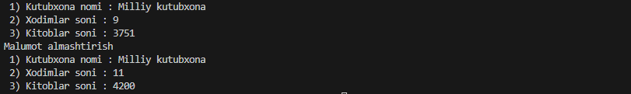

1. Xodim nomli sinf yarating. Tarkibida statik a’zolar va statik metodlar mavjud bo’lsin.

#include <iostream>

using namespace std;

class Kutubxona

{

private:

    static string nom;

    static int xodim;

    static int kitob;

public:

    static void Set(int b, int c)

    {

        xodim = b;

        kitob = c;

    }

    static void Print()

    {

        cout << " 1) Kutubxona nomi : " << nom << endl;

        cout << " 2) Xodimlar soni : " << xodim << endl;

        cout << " 3) Kitoblar soni : " << kitob << endl;

    }

};

string Kutubxona::nom = "Milliy kutubxona";

int Kutubxona::xodim = 9;

int Kutubxona::kitob = 3751;

int main()

{

    Kutubxona::Print();

    Kutubxona::Set(11, 4200);

    cout << "Malumot almashtirish" << endl;

    Kutubxona::Print();

    return 0;

}

// Natija

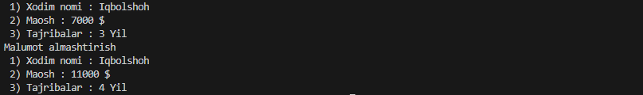

1. Korxona nomli sinf yarating. Tarkibida statik a’zolar va statik metodlar mavjud bo’lsin.

#include <iostream>

using namespace std;

class Korxona

{

public:

    static string korxonaNomi;

    static int ishchilarSoni;

    static void Print()

    {

        cout << "Korxona nomi: " << korxonaNomi << endl;

        cout << "Ishchilar soni: " << ishchilarSoni << endl;

    }

    static void Set(int newIshchilarSoni)

    {

        ishchilarSoni = newIshchilarSoni;

    }

};

string Korxona::korxonaNomi = "Tibbiyot Korxonasi";

int Korxona::ishchilarSoni = 100;

int main()

{

    Korxona::Print();

    Korxona::Set(120);

    cout << "Malumot almashtirish" << endl;

    Korxona::Print();

    return 0;

}

// Natija

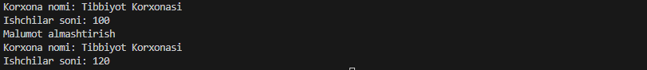

1. Shahar nomli sinf yarating. Tarkibida statik a’zolar va statik metodlar mavjud bo’lsin.

#include <iostream>

using namespace std;

class Shahar

{

private:

    static string nom;

    static int yil;

    static int aholi;

public:

    static void Set(int b, int c)

    {

        yil = b;

        aholi = c;

    }

    static void Print()

    {

        cout << " 1) Shahar nomi : " << nom << endl;

        cout << " 2) Yil : " << yil << endl;

        cout << " 3) Aholi soni : " << aholi << endl;

    }

};

string Shahar::nom = "Samarqand";

int Shahar::yil = 2022;

int Shahar::aholi = 1555000;

int main()

{

    Shahar::Print();

    Shahar::Set(2023, 1775000);

    cout << "Malumot almashtirish" << endl;

    Shahar::Print();

    return 0;

}

// Natija

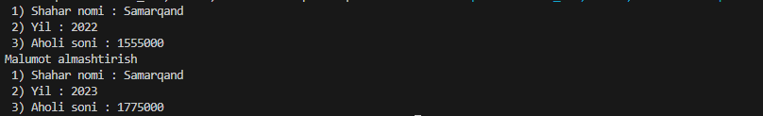

1. Viloyat nomli sinf yarating. Tarkibida statik a’zolar va statik metodlar mavjud bo’lsin.

#include <iostream>

using namespace std;

class Viloyat

{

private:

    static string nom;

    static int maydoni;

    static int aholi;

public:

    static void Set(int b, int c)

    {

        maydoni = b;

        aholi = c;

    }

    static void Print()

    {

        cout << " 1) Viloyat nomi : " << nom << endl;

        cout << " 2) Maydoni : " << maydoni << "km kv" << endl;

        cout << " 3) Aholi soni : " << aholi << endl;

    }

};

string Viloyat::nom = "Samarqand";

int Viloyat::maydoni = 120;

int Viloyat::aholi = 1750000;

int main()

{

    Viloyat::Print();

    Viloyat::Set(150, 2200000);

    cout << "Malumot almashtirish" << endl;

    Viloyat::Print();

    return 0;

}

// Natija

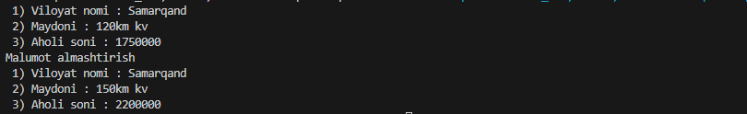

1. Futbol komandasi nomli sinf yarating. Tarkibida statik a’zolar va statik metodlar mavjud bo’lsin.

#include <iostream>

using namespace std;

class Futbol

{

private:

    static string JamoaNomi;

    static string stadion;

    static int fudbolchi;

public:

    static void Set(string a, int c)

    {

        JamoaNomi = a;

        fudbolchi = c;

    }

    static void Print()

    {

        cout << " 1) Jamoa Nomi : " << JamoaNomi << endl;

        cout << " 2) Stadion nomi : " << stadion << endl;

        cout << " 3) Tudbolchi soni : " << fudbolchi << endl;

    }

};

string Futbol::JamoaNomi = "Real madrid";

string Futbol::stadion = "Borg El Arab";

int Futbol::fudbolchi = 11;

int main()

{

    Futbol::Print();

    Futbol::Set("Juventus", 12);

    cout << "Malumot almashtirish" << endl;

    Futbol::Print();

    return 0;

}

// Natija

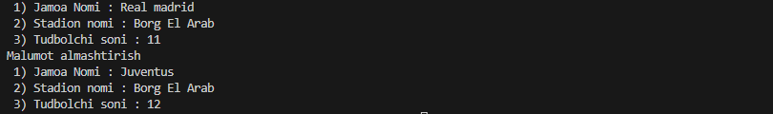

1. Dekanat nomli sinf yarating. Tarkibida statik a’zolar va statik metodlar mavjud bo’lsin.

#include <iostream>

using namespace std;

class Dekanat

{

private:

    static string fakultet;

    static string dekan;

    static int talaba;

public:

    static void Set(string a, string b, int c)

    {

        fakultet = a;

        dekan = b;

        talaba = c;

    }

    static void Print()

    {

        cout << " 1) Fakultet : " << fakultet << endl;

        cout << " 2) Dekan : " << dekan << endl;

        cout << " 3) Talabalar soni : " << talaba << endl;

    }

};

string Dekanat::fakultet = "Intelektular tizimlar";

string Dekanat::dekan = "Nazarov Fayzullo";

int Dekanat::talaba = 1500;

int main()

{

    Dekanat::Print();

    Dekanat::Set("Matematika", "Ilhomjonov Iqbolshoh", 2200);

    cout << "Malumot almashtirish" << endl;

    Dekanat::Print();

    return 0;

}

// Natija

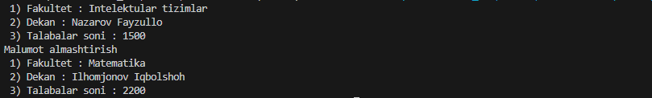

1. Shifoxona nomli sinf yarating. Tarkibida statik a’zolar va statik metodlar mavjud bo’lsin.

#include <iostream>

using namespace std;

class Shifoxona

{

private:

    static string nom;

    static int xodim;

    static int bemor;

public:

    static void Set(int b, int c)

    {

        xodim = b;

        bemor = c;

    }

    static void Print()

    {

        cout << " 1) Shifoxona nomi : " << nom << endl;

        cout << " 2) Xodim soni : " << xodim << endl;

        cout << " 3) Bemor soni : " << bemor  << endl;

    }

};

string Shifoxona::nom = "Markaziy shifoxona";

int Shifoxona::xodim = 55;

int Shifoxona::bemor = 257;

int main()

{

    Shifoxona::Print();

    Shifoxona::Set(77, 354);

    cout << "Malumot almashtirish" << endl;

    Shifoxona::Print();

    return 0;

}

// Natija

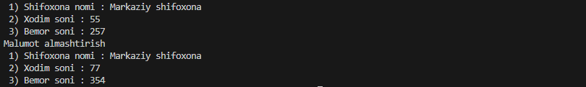

1. GeometrikShakl nomli sinf yarating. Tarkibida statik a’zolar va statik metodlar mavjud bo’lsin.

#include <iostream>

using namespace std;

class GeometrikShakl

{

private:

    static string nom;

    static int a;

    static int b;

    static int c;

public:

    static void Set(int aa, int bb, int cc)

    {

        a = aa;

        b = bb;

        c = cc;

    }

    static void Print()

    {

        cout << " 1) Shakl nomi : " << nom << endl;

        cout << " 2) a : " << a << endl;

        cout << " 3) b : " << b << endl;

        cout << " 4) b : " << c << endl;

    }

};

string GeometrikShakl::nom = "Uchburchak";

int GeometrikShakl::a = 3;

int GeometrikShakl::b = 4;

int GeometrikShakl::c = 5;

int main()

{

    GeometrikShakl::Print();

    GeometrikShakl::Set(7, 7, 7);

    cout << "Malumot almashtirish" << endl;

    GeometrikShakl::Print();

    return 0;

}

// Natija

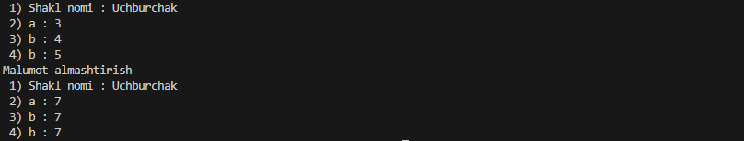

1. Soat nomli sinf yarating. Tarkibida statik a’zolar va statik metodlar mavjud bo’lsin.

#include <iostream>

using namespace std;

class Soat

{

private:

    static string turi;

    static string brendi;

    static int narxi;

public:

    static void Set(string b, int c)

    {

        brendi = b;

        narxi = c;

    }

    static void Print()

    {

        cout << " 1) Soat turi : " << turi << endl;

        cout << " 2) Brendi : " << brendi << endl;

        cout << " 3) Narxi : " << narxi << "$" << endl;

    }

};

string Soat::turi = "Qo'l soat";

string Soat::brendi = "Jacob & co";

int Soat::narxi = 150000;

int main()

{

    Soat::Print();

    Soat::Set("Electron", 354);

    cout << "Malumot almashtirish" << endl;

    Soat::Print();

    return 0;

}

// Natija

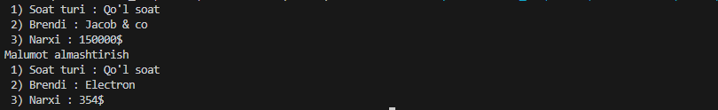

1. Telefon nomli sinf yarating. Tarkibida statik a’zolar va statik metodlar mavjud bo’lsin.

#include <iostream>

using namespace std;

class Telefon

{

private:

    static string nomi;

    static string brendi;

    static int narxi;

public:

    static void Set(string b, int c)

    {

        nomi = b;

        narxi = c;

    }

    static void Print()

    {

        cout << " 1) Telefon nomi : " << nomi << endl;

        cout << " 2) Brendi : " << brendi << endl;

        cout << " 3) Narxi : " << narxi << "$" << endl;

    }

};

string Telefon::nomi = "14 pro max";

string Telefon::brendi = "Apple";

int Telefon::narxi = 1300;

int main()

{

    Telefon::Print();

    Telefon::Set("13 pro", 450);

    cout << "Malumot almashtirish" << endl;

    Telefon::Print();

    return 0;

}

// Natija

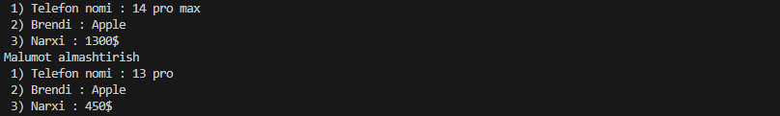

1. Mashina nomli sinf yarating. Tarkibida statik a’zolar va statik metodlar mavjud bo’lsin.

#include <iostream>

using namespace std;

class Mashina

{

private:

    static string nomi;

    static string brendi;

    static int narxi;

public:

    static void Set(string b, int c)

    {

        nomi = b;

        narxi = c;

    }

    static void Print()

    {

        cout << " 1) Mashina nomi : " << nomi << endl;

        cout << " 2) Brendi : " << brendi << endl;

        cout << " 3) Narxi : " << narxi << "$" << endl;

    }

};

string Mashina::nomi = "Model S";

string Mashina::brendi = "Tesla";

int Mashina::narxi = 77000;

int main()

{

    Mashina::Print();

    Mashina::Set("Model Y", 57000);

    cout << "Malumot almashtirish" << endl;

    Mashina::Print();

    return 0;

}

// Natija

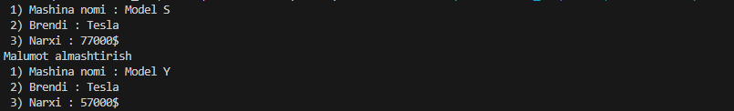

1. Talaba nomli sinf yarating. Tarkibida statik a’zolar va statik metodlar mavjud bo’lsin.

#include <iostream>

using namespace std;

class Talaba

{

private:

    static string nom;

    static int kurs;

    static int guruh;

public:

    static void Set(int b, int c)

    {

        kurs = b;

        guruh = c;

    }

    static void Print()

    {

        cout << " 1) Talaba ismi : " << nom << endl;

        cout << " 2) Kurs : " << kurs << endl;

        cout << " 3) Guruh : " << guruh << endl;

    }

};

string Talaba::nom = "Iqbolshoh";

int Talaba::kurs = 2;

int Talaba::guruh = 204;

int main()

{

    Talaba::Print();

    Talaba::Set(3, 304);

    cout << "Malumot almashtirish" << endl;

    Talaba::Print();

    return 0;

}

// Natija

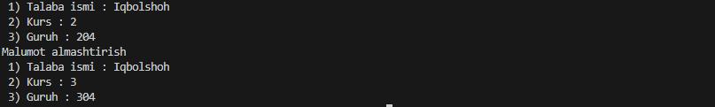

1. Universitet nomli sinf yarating. Tarkibida statik a’zolar va statik metodlar mavjud bo’lsin.

#include <iostream>

using namespace std;

class Universitet

{

private:

    static string nom;

    static int fakultet;

    static int talaba;

public:

    static void Set(int b, int c)

    {

        fakultet = b;

        talaba = c;

    }

    static void Print()

    {

        cout << " 1) Universitet nomi : " << nom << endl;

        cout << " 2) Fakultet soni : " << fakultet << endl;

        cout << " 3) Talabalar soni : " << talaba << endl;

    }

};

string Universitet::nom = "SamDU";

int Universitet::fakultet = 14;

int Universitet::talaba = 28000;

int main()

{

    Universitet::Print();

    Universitet::Set(16, 32000);

    cout << "Malumot almashtirish" << endl;

    Universitet::Print();

    return 0;

}

// Natija

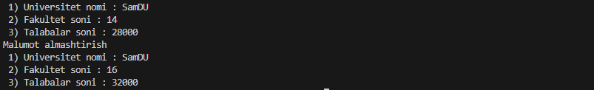

1. Kafedra nomli sinf yarating. Tarkibida statik a’zolar va statik metodlar mavjud bo’lsin.

#include <iostream>

using namespace std;

class Kafedra

{

private:

    static string nom;

    static int oqituvchi;

    static int fan;

public:

    static void Set(int b, int c)

    {

        oqituvchi = b;

        fan = c;

    }

    static void Print()

    {

        cout << " 1) Kafedra nomi : " << nom << endl;

        cout << " 2) O'qituvchilar soni : " << oqituvchi << endl;

        cout << " 3) Fanlar soni : " << fan << endl;

    }

};

string Kafedra::nom = "Dasturiy injinering";

int Kafedra::oqituvchi = 17;

int Kafedra::fan = 22;

int main()

{

    Kafedra::Print();

    Kafedra::Set(15, 24);

    cout << "Malumot almashtirish" << endl;

    Kafedra::Print();

    return 0;

}

// Natija

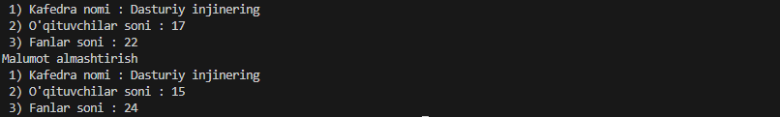

1. Maktab nomli sinf yarating. Tarkibida statik a’zolar va statik metodlar mavjud bo’lsin.

#include <iostream>

using namespace std;

class Maktab

{

private:

    static string nom;

    static int oqituvchi;

    static int talaba;

public:

    static void Set(int b, int c)

    {

        oqituvchi = b;

        talaba = c;

    }

    static void Print()

    {

        cout << " 1) Maktab nomi : " << nom << endl;

        cout << " 2) O'qituvchilar soni : " << oqituvchi << endl;

        cout << " 3) Talabalar soni : " << talaba << endl;

    }

};

string Maktab::nom = "33-Maktab";

int Maktab::oqituvchi = 77;

int Maktab::talaba = 1300;

int main()

{

    Maktab::Print();

    Maktab::Set(88, 1400);

    cout << "Malumot almashtirish" << endl;

    Maktab::Print();

    return 0;

}

// Natija

